**How to do Check-in /Commit ?**

1. Initially copy the files from BR17.XX folder and copy it in ORCA-data and Open production machine and go to E:/FTP/data.

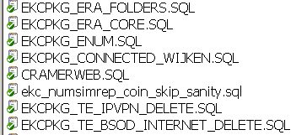

1. Open E:\Baheer\SubVersion\Customisations\Ziffo_Cramer\DBServer\Packages_cust or \Packages_cramer
2. Here you need to copy the packages files for example If it is EKCPKG_WANDL_COMPARE.sql

These needs to be commit by copying the package which is under cust to the above path.

If it is cramer package you needs to copy in E:\Baheer\SubVersion\Customisations\Ziffo_Cramer\DBServer\Packages_Cramer

1. 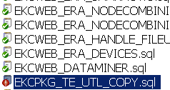
2. Once you try to copy your package it will ask to you a message like “ Do you want to override the file “ then give yes if it is a relevant file.
3. Then the colour should be changed to red from green.
4. Go to the above file and do right click and select SVN COMMIT and immediately one window opens like below.

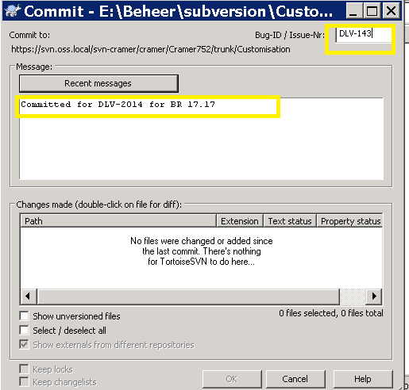

Click on Ok you will see the last committed one.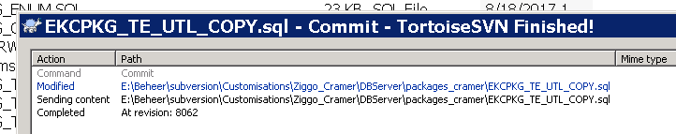

1. Once it is Completed do refresh and check weather file is changed from red to Green colour or not.
2. If yes, then commit is done properly.

Case ii)

If you are adding a new file which is not present in the path.

Then you just copy the package file and copy in the proper path then the colour is blue as mentioned below.

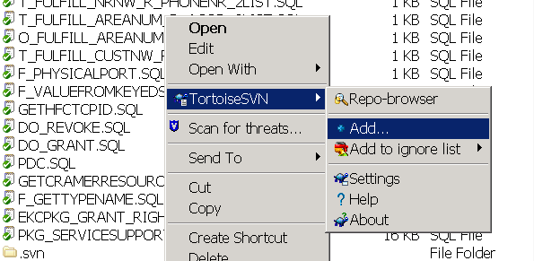

After adding it properly then it should be in blue colour like this.

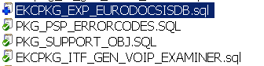

Once the file is added properly Go to properties as showed below.

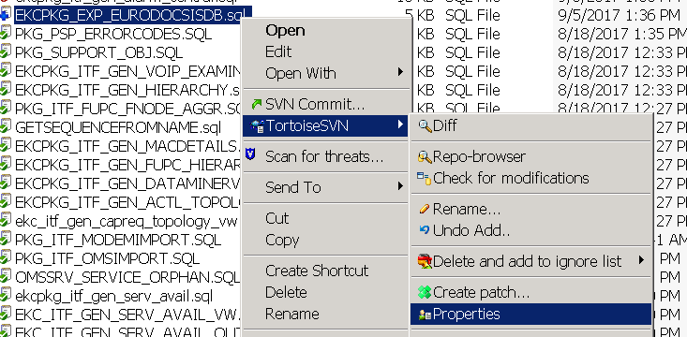

Here one window opens

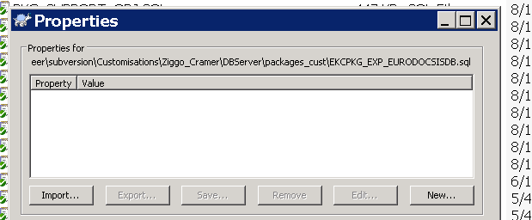

Select Import and then it will open another window.

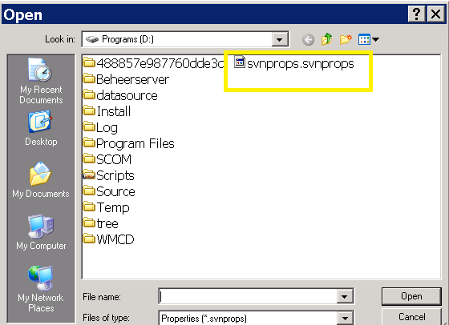

Select the yellow marked file and then open it.Once you click on open it will open another window and just click ok as showed below.

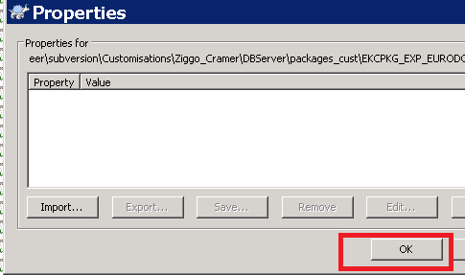

And then finally Do commit By selecting file and then click on svn commit like below.

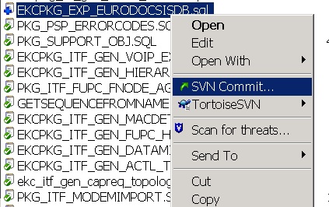



Once you click on Okay. Finally one window will generate with SVN finished.



This is the final step so in this way we can do commit for new files and existing files.

NOTE: since we are not able to copy the dlv packages directly in production. First we need to copy the folder in E:/FTP/ORCA-data from here you can start checking one by one and You need to follow the proper order while doing commit.Please check Cust and Cramer folders properly and check for the packages under that folders. You have to do commit if it is cust related package you need to do commit on PACKAGES_CUST. If you have to do commit if it is Cramer related package you need to do commit on PACKAGES_CRAMER.